Data Set 1:

**Top 3 States in the U.S. that Produced the Highest Amount of Maternal mortality of Black Women in 2019**

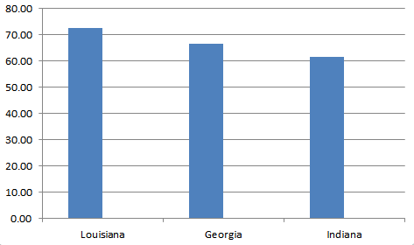

**States**

**Maternal Mortality Rate per 100,000 Live Births**

Data Set 2:

**Maternal Mortality Rates Among Women of Color Across the Nation in 2019**

**Race**

**Maternal Mortality Rate per 100,000 Live Births**